Carbody Structure and Exterior

Introduction

Use

Purpose

Parts List

All figures are assigned to an individual page unless views are required to show a complete listing of equipment.

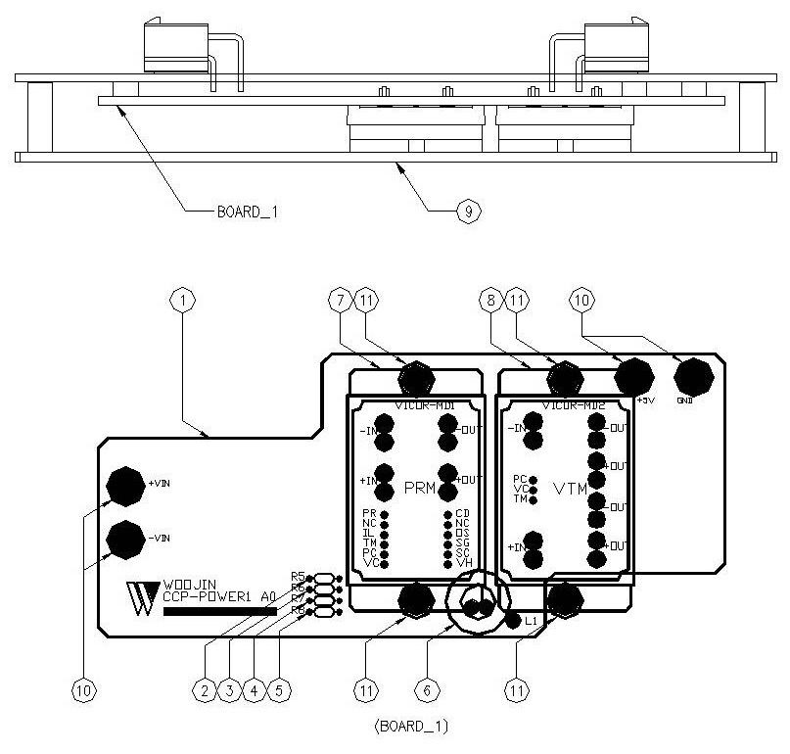

Figure 2.1. CCP Power Board1
Table 1 - Figure 2.1. CCP Power board1
FIG No. | PART NUMBERS |  |  | ITEM DESCRIPTION | VENDOR CODE | QTY
 | HRC | VENDOR | DTP
1 |  | CCP-POWER1 A0 |  | . BOARD | HANSAEM | 1
2 |  | MR1/8W15ΩFTB  MFR0318FAEW0150MA  SN1/8KT52R15ΩF |  | . CARBON FILM RESISTOR | ABCO  RARA  JEIL | 1
3 |  | MR1/8W2KΩFTB  MFR0318FAEW2001MA  SN1/8KT52R2KΩF |  | . CARBON FILM RESISTOR | ABCO  RARA  JEIL | 1
4 |  | MR1/8W820ΩFTB  MFR0318FAEW8200MA  SN1/8KT52R820ΩF |  | . CARBON FILM RESISTOR | ABCO  RARA  JEIL | 1
5 |  | MR1/8W8.2ΩFTB  MFR0318FAEW8R20MA  SN1/8KT52R8.2ΩF |  | . CARBON FILM RESISTOR | ABCO  RARA  JEIL | 1
6 |  | 4uH/10A, Φ12, CH127125 |  | . POWER INDUCTOR | TAESUNG  DAEKWANG | 1
7 |  | PR036A480T012FP |  | . DC/DC CONVERTER | VICOR | 1
8 |  | VT048A060T040FP |  | . DC/DC CONVERTER | VICOR | 1
9 |  | AI, D153 X L57 X H16 |  | . HEAT SINK | EGPOWER | 1
10 |  | PEMNUT M3X6 |  | . PEM NUT | EGPOWER | 4
11 |  | ROUND, M3XL6mm |  | . BOLT |  | 4

